**Samsung's new payment card solution blends security IC with biometrics.**

No need to enter PINs with this new security layer.



In a nutshell, Samsung unveiled a new payment card security solution this week. It combines a fingerprint sensor, a security chip, and other components to simplify card authentication while simultaneously providing an additional layer of security.

When paired with a security chip and secure processor, Samsung's fingerprint sensor, codenamed S3B512C, adds a new layer of protection. Although it's primarily designed for payment cards, Samsung claims it may also be used for other types of authentication, such as employee IDs or membership cards. Users should be able to use their cards without inputting their PINs thanks to the authentication technology.

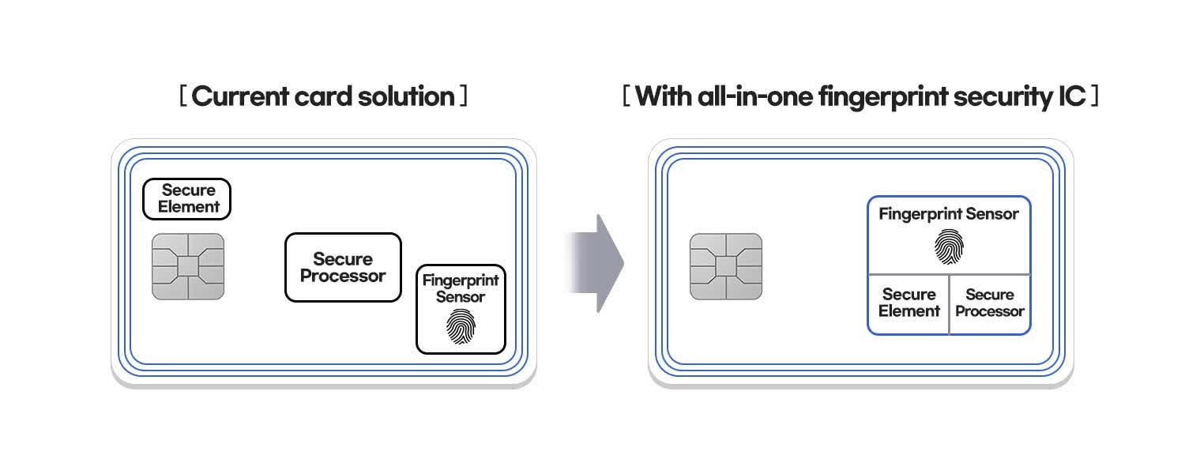

This is the world's first security chip that scans fingerprint information, according to Samsung. It stores and authenticates encrypted biometric data with the Secure Element before analysing it with the Secure Processor. It's also EMVCo and Common Criteria Evaluation Assurance Level 6+ certified. Mastercard's newest Biometric Evaluation Plan Summary for payment cards is compatible with the technology.

Mastercard announced in August that it would begin phasing out obsolete magnetic strip authentication in favour of more secure chips in 2024, albeit it would not completely phase out the strip until 2033. Despite this, tales have surfaced of hackers brute-forcing credit card data and then selling them on the dark web. Fingerprint authentication is ineffective in this region.